RELIGION | LITERACY | MATH | STEM | SPECIALS
listen to Catholic Sprouts podcast | Read a book about summer | Put on your swim suit and explore with water outside. How far can a hose sray? 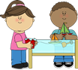 | Plant a flower garden, or plant some seeds in a pot, water and set in the sun and watch them grow. 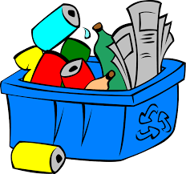 | Go on a Treasure Hunt
Say a Thank You Prayer | 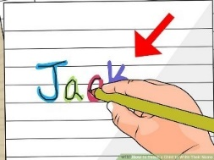  Practice name writing on your name sheet | Sort coins by size, color, and value. Which pile has the most/least? | Make an ice cream shop for your family. Make signs and a price list. Have ice cream, a scoop, sprinkles. Have your family be your customers. | Do Ocean animal walks. Crawl like a crab, swim like a fish, etc.
Pray the Our Father | 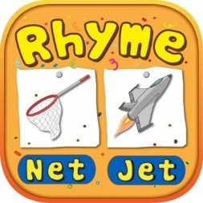  Use tiny treasures like gems to spell out your name and other words. | Make sidewalk paint, ¼ cup cornstarch,1/4 cup water, a few squirts of food coloring. Mix together. | Build an obsticle course. Jump over stuffed animals, go through chairs, go around pots. Or build it outside. | 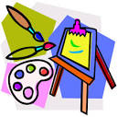Make a pressed flowers picture with waxed paper or contact paper.
Pray the Hail Mary | Act out a story. Use props and change you voice for different characters. | 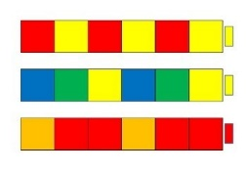  Blow bubbles. Use string to measure how far they travel. | Build a “sand” castle with any supplies that you might have. | Camp out in your backyard. Look at the stars at night.

