RELIGION | LITERACY | MATH | STEM | SPECIALS
listen to Catholic Sprouts podcast | Read a book about Moms | sprinkle salt, oatmeal, sand on a cookie sheet. Practice writing numbers 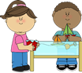 | Place spaghetti noodles in playdough thread beads, cereal, or cut up straws on the noodles 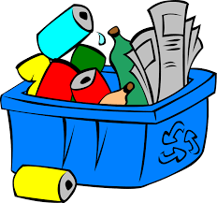 | Choose one thing you can do today to be helpful to your mom.
Talk about Mary and how she is the Blessed Mother of Jesus | 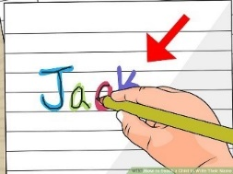  Practice name writing on your name sheet | Count how many forks and spoons you have. Which pile has the most/least? | What are moms of different animals called?  Chicken-hen,  Lion-lioness, | Play  Mother May I
Pray the Our Father | Draw a picture of your mom | Bake a yummy treat for your mom. Use the recipe to measure ingredients. | Build a comfy, quiet place for your mom to relax using pillows, blankets, etc. Maybe read her a book or tell her a story. | 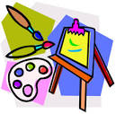  Paint with kitchen tools, forks, mashers, whisk, etc.
Pray the Hail Mary | Ask your mom questions about her. What is her favorite color, food, animal? What does she like to do to relax? What does she like to do with you? | Roll a dice and count out the same number of blocks. Add the blocks to make a tower. | Make a spa for your mom. Play soothing music. Rub her feet, neck, shoulders. | Have a clean up race. Play music and see how many songs it takes you to clean up.

